Question 1 :

Factorial.java

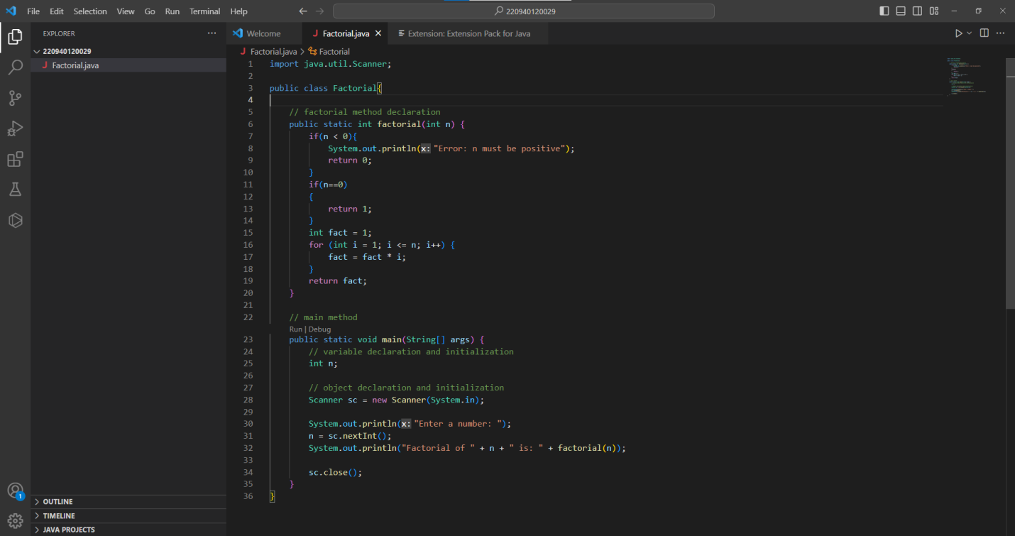

Create a remote repository on GitHub

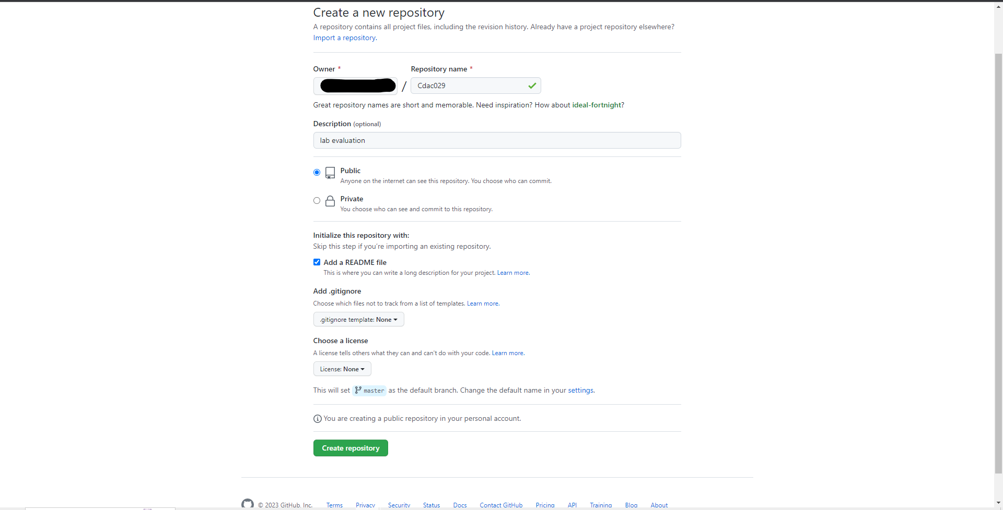

Remote repository created

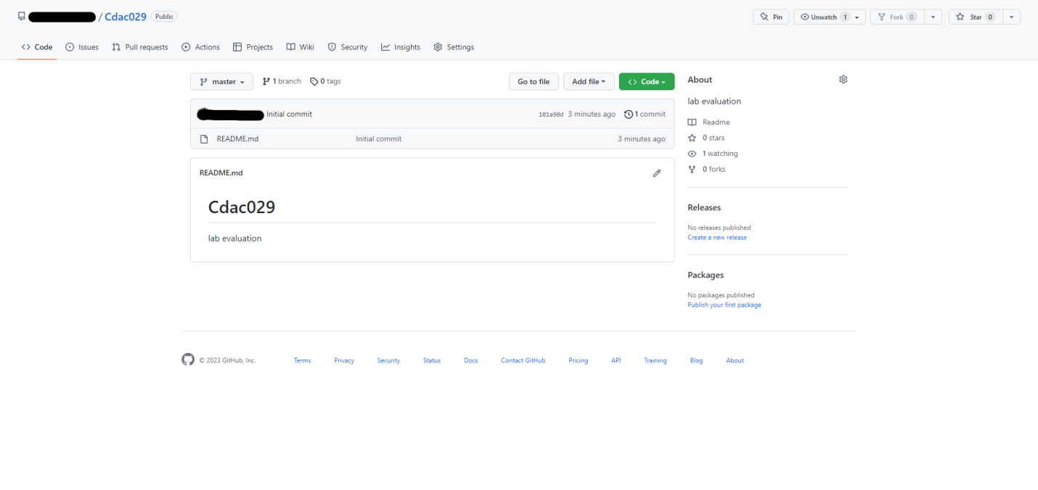

Generate Personal Access Token

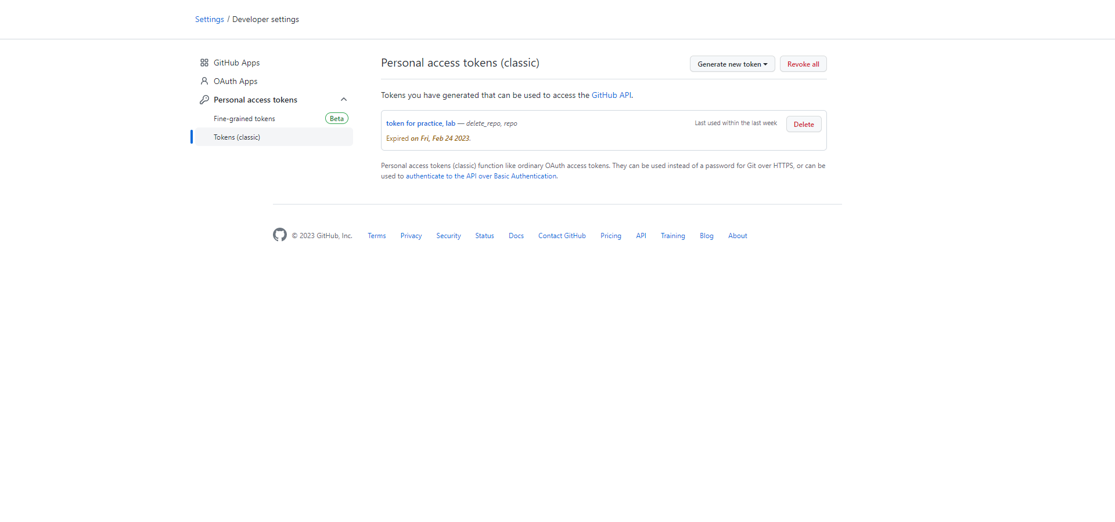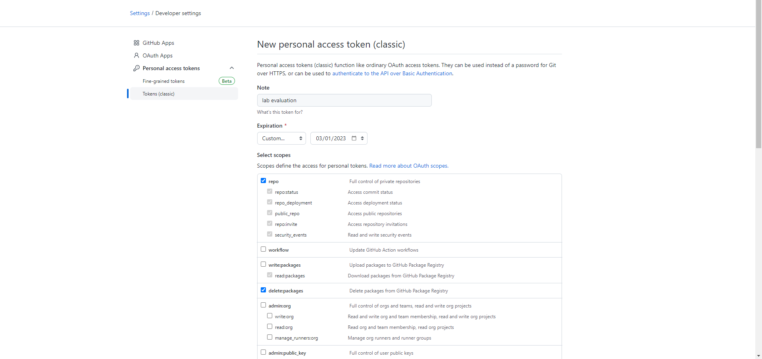

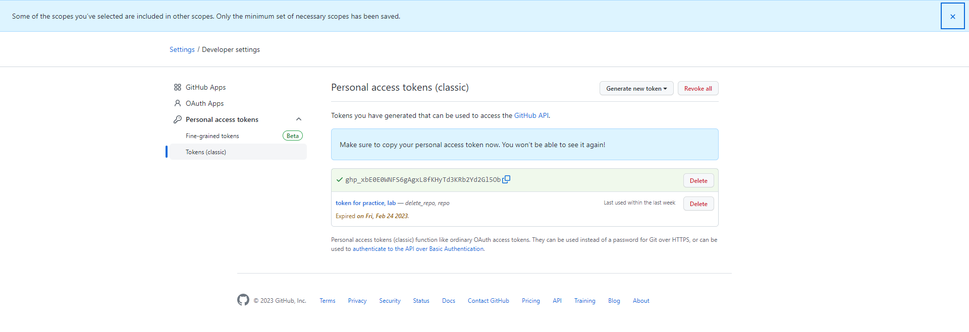

# to initialize git in the directory

Git Bash : git init

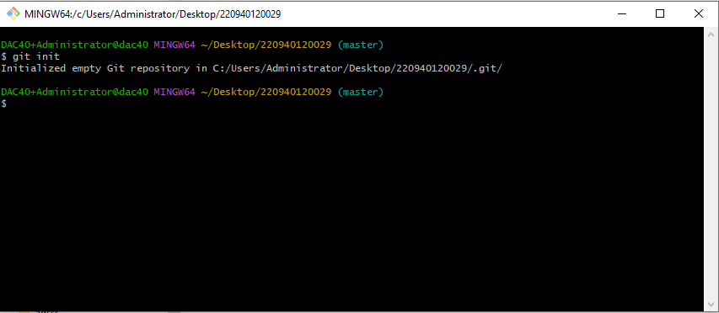

# to add all files in current directory to the staging area

Git Bash : git add .

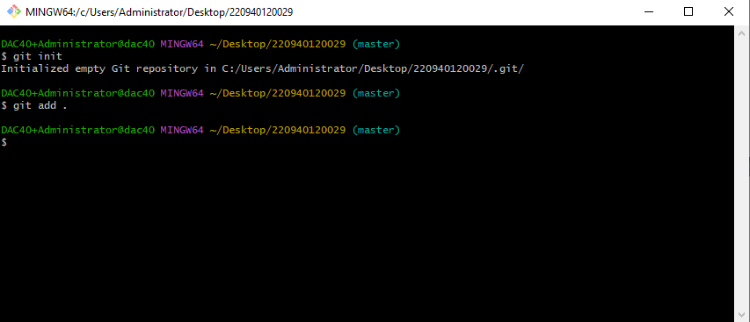

# commit to local repo

Git Bash : git commit –m “Initial Commit for Factorial.java”

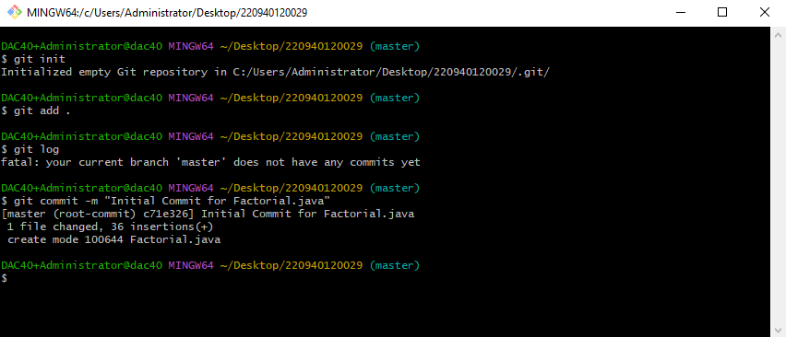

# add remote repository   
Git Bash : git remote add origin https://github.com/Anchal-Panda/Cdac029.git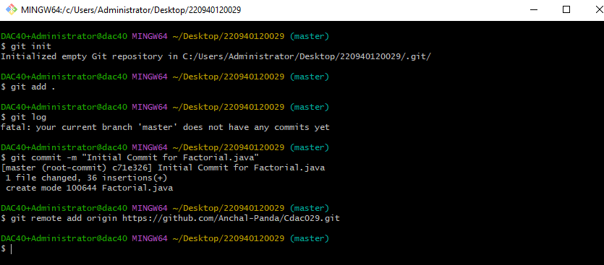

# push to remote repository after login through token  
Git Bash : git push -u origin master

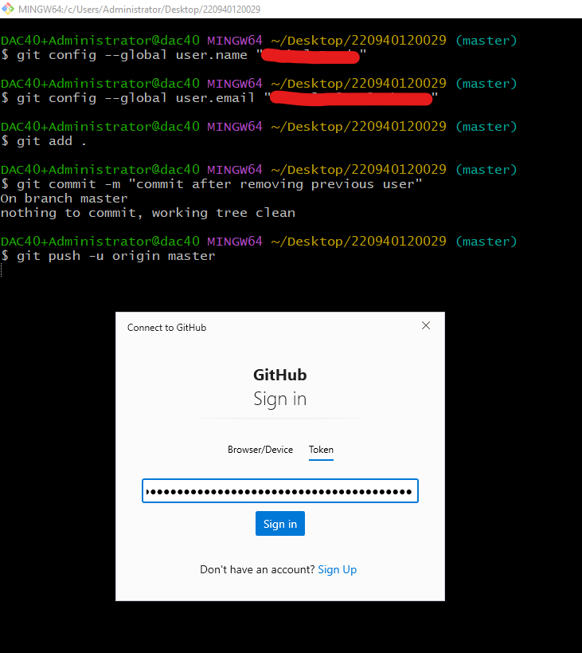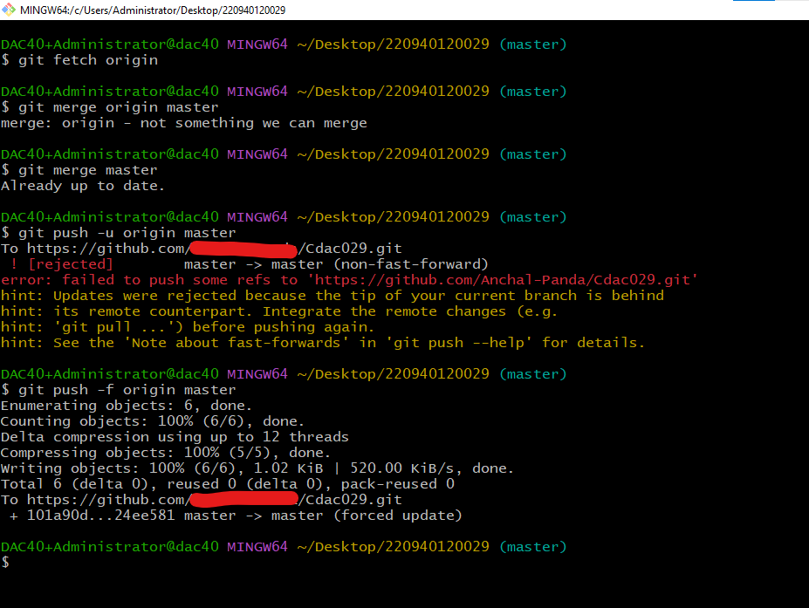

Files pushed to remote repository

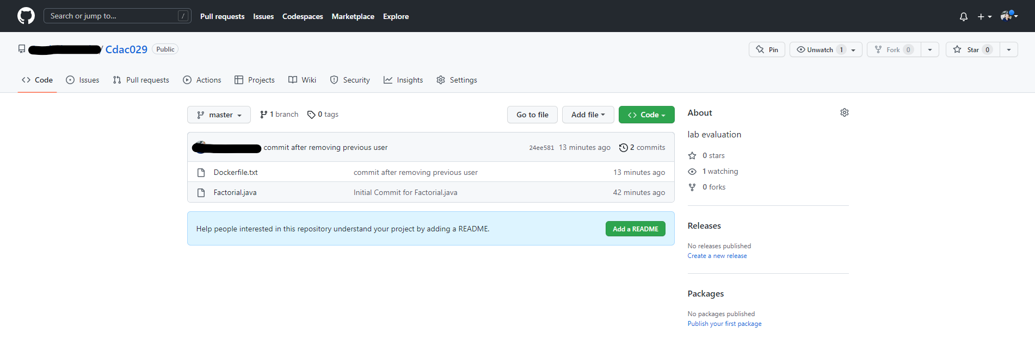

https://stackoverflow.com/questions/11696295/rejected-master-master-non-fast-forward